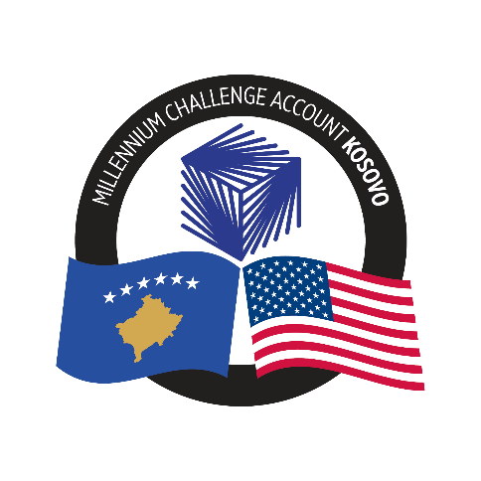

**Millenium Challenge Account (MCA) – KOSOVO**

**APPLICATION FORM**

**Please indicate the position you are applying for:** **_______________________________________**

**Guidance Notes on Completing the Application Form:**

|  |
| --- |
| The below explanation will help you to complete the application form to the best of your ability and gain an understanding of what you can expect from this process.  The application form consists of three main parts:  ***Part A: Personal Details, Career History, E*ducation and Professional Qualifications**  ***Part B: Statement of Suitability (Cover Letter)***  ***Part C: List of at least three references***  The evidence you provide in your application form will be used in the shortlisting process to decide whether you will proceed to the next stage. Please complete the form accurately and include all the requested information. If you do not complete the form fully, it may be rejected on the basis of lack of evidence. The duly filled-out Application Form is to be submitted electronically through the email address given in the Vacancy Notice, together with an up-to-date CV. **CVs without additional required documents are not accepted.**  The working language of the MCA-Kosovo is English; **therefore, you are required to complete the application form in English.** |

**Part A: Personal Details and Career History**

**1. PERSONAL DETAILS**

|  |  |
| --- | --- |
| Surname: | Telephone number (Home): |
| Forenames: | Telephone number (Mobile): |
| Postal Address: | E-mail Address: |
| Postcode: | Nationality: |

**2. EMPLOYMENT HISTORY**

**a) Current Employment**

Please give details of your present or most recent employment:

|  |  |  |  |
| --- | --- | --- | --- |
| **Name and Address of Employer and Nature of Business:** | **Dates of employment**  **From:**  **To:** | **Job Title**  Key purpose of role /  Key responsibilities | **Reporting to**  (i.e. the organisational level to which your role reports) |
|  |  |  |  |

**b) Past Employment History**

|  |  |  |  |
| --- | --- | --- | --- |
| **Name and Address of Employer and Nature of Business:** | **Dates of employment**  **From:**  **To:** | **Job Title**  Key purpose of role /  Key responsibilities | **Reporting to**  (i.e. the organisational level to which your role reported) |
|  |  |  |  |

***\*Please add as needed***

**3. EDUCATION AND PROFESSIONAL QUALIFICATIONS**

You should refer to the position description for this role and **ensure that you provide evidence that you meet the minimum requirements for this position - namely** **an academic degree (as indicated in the Vacancy Notice)**.

|  |  |  |
| --- | --- | --- |
| Degree, field, and institution attending the studies | Level of study  Dates (studied from/to) | Date of the award/degree obtained |
|  |  |  |

**Professional Qualifications / Occupational Training / Membership of Professional Societies**

|  |  |
| --- | --- |
| Professional or other qualifications, membership of professional societies and date admitted, where relevant | Details of publications, presentations at international conferences (etc.) relevant to the role |
|  |  |

|  |
| --- |
| Details of other specialist training / courses attended relevant to the role |
|  |

**LANGUAGES**

**Level 4 (Fluent) of English-language speaking and written capability is required**.

Please tick (√) to self-declare your ability to meet this standard:

Level 4 Speaking

Level 4 Reading/Writing

**Level 4 (Fluent) of another official language of Kosovo (Albanian or Serbian) is required.   
Proficiency in Albanian is preferred for candidates who speak Serbian, and vice versa.**

Please tick (√) to self-declare your ability to meet this standard:

Albanian Level 4 Speaking

Albanian Level 4 Reading/Writing

**or**

Serbian Level 4 Speaking

Serbian Level 4 Reading/Writing

Please add and tick (√) in any relevant boxes below to indicate any other languages that you can speak and/or understand and the level of this capability

|  |  |  |  |  |
| --- | --- | --- | --- | --- |
| Any other languages | Level 1 –  Basic / beginner | Level 2 –Threshold/ intermediate | Level 3 –  Operational | Level 4 –  Fluent |
| 1. Language (please add): |  |  |  |  |
| 1. Spoken |  |  |  |  |
| 1. Written |  |  |  |  |
| 2. Language (please add): |  |  |  |  |
| 1. Spoken |  |  |  |  |
| 1. Written |  |  |  |  |

**Part B: Statement of Suitability and Evidence against the Position Vacancy Notice (Cover Letter)**

1. **Statement of Suitability (Cover Letter - no more than 1 page)**

This is your opportunity to tell us why you are suitable for the position and to highlight your relevant achievements. Tell us how you think you can deliver the demanding requirements of this particular job. Ensure you structure your supporting statement clearly and coherently, referencing how your skills and experience will help you to do this.

**In assessing your evidence we will disregard anything beyond one page.**

**In particular, please include:**

* **A description of programs you have managed, including program budget, and the number of personnel you have managed;**
* **Examples of experience in working with high-level government officials**
* **Examples of experience in working with the relevant technical area for the program as per the Vacancy Notice;**

**CVs will not be accepted in lieu of this statement.**

**Part C: Professional References:**

Please list at least three professional references, with at least one of them a former Supervisor. For each reference please include:

* Name, Surname;
* Current Position Title and their relationship with you;
* Complete and current contact information (phone number and email address).

**SPECIAL REQUIREMENTS**

Please list below any special requirements or reasonable adjustments that you may have if you are shortlisted for this role.

|  |
| --- |
|  |

Does anyone in your family or household work (or intern) for MCA-Kosovo?

Yes

No

If yes, please provide the below details:

Name and Surname: _______________________________________________________

Position (engagement) with MCA-K: __________________________________________

Family or household relationship: _____________________________________________

**DECLARATIONS**

|  |
| --- |
| I declare that this application form has been completed by me and that the information I have given is true to the best of my knowledge and belief. I understand that if I have given any information that I know is false, or if I withhold any relevant information it may lead to my application being rejected, or if appointed, to my dismissal.  Please type your name and surname to confirm this declaration: **_____________________**  Signature: **_____________________**  Date:  I declare that I am not currently under investigation or convicted for criminal acts.  *Please note that at this stage we do not require you to submit a current certificate to prove this, but the original court and police certified copies will be required at a later stage of the recruitment process.*  Signature: **_____________________**  Date: |