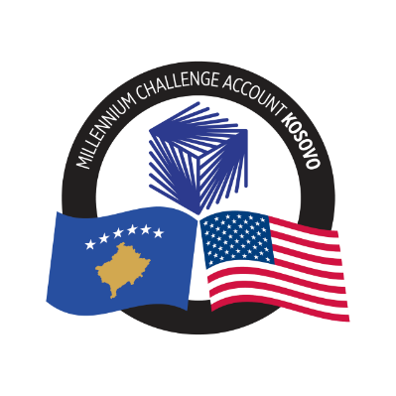
MCA-KOSOVO

CONTRACT AWARD NOTICE

Country | : | Kosovo
City/Locality | : | Prishtina
Funding Agency | : | Millennium Challenge Corporation
Buyer | : | Millennium Challenge Account – Kosovo

To promote transparency and in accordance with the MCC Accountable Entity Program Policy and Guidelines, MCA-Kosovo publishes the contract awards notice.
A notice must be published at least monthly on the Accountable Entity website and identify the contracts signed within the last 30 days including contracts awarded by Limited Bidding, Direct Contracting and Sole Source Selection procedures.

The following contracts has been awarded during the period of June 2024.

Goods and Non-Consultant Services
Number and Name of the Procurement | Selected Offeror | Contract Amount | Contract Period | Scope of the goods/Non-Consultant Services
24-3006  Event Planning & Management services for MCA-Kosovo | Pi Communication Sh.P.K. | Blanket Purchase Agreement with the ceiling amount of US$ 68,600.00  (Sixty-Eight Thousand, Six Hundred US Dollars) | Blanket Purchase Agreement (BPA) with duration 12 months | Event planning and management services to MCA-Kosovo when needed based on the unit prices included in the BPA based on the offer.
24-1005  Computer Equipment for KOSTT PIU | Storm ICT L.L.C | € 21,420.00  (Twenty-One Thousand, Four Hundred Twenty Euros) | Signed on June 24, 2024.  Delivery period maximum 30 Days from the issuance of the contract: | Supply and delivery of computer equipment for KOSTT PIU, including high-end laptops, mid-range laptops, and external screens/monitors

Consultant Services (Firms)
Number and Name of the Procurement | Selected Offeror | Contract Amount | Contract Period | Scope of the Services
23-4001  Recruitment of a Training Consultant for the MESPI Capacity Building Activity | Planet S.A. | Total € 1,284,850.00 Euro  (One million two hundred eighty-four thousand eight hundred fifty Euro)  Base Period (12 months): 345,000.00 Euro  Option Period 1 (12 months): 260,650.00 Euro  Option Period 2 (12 months): 246,250.00 Euro  Option Period 3 (12 months): 230,800.00 Euro  Option Period 4 (10 months): 202,150.00 Euro | From June 21, 2024, up to April 29, 2029 (before the Compact End Date) | Training and capacity building in international ESIA standards for GoK staff as well as the technical aspects, environmental, social and gender responsive approach and impacts and appropriate mitigation measures for Renewable Energy Systems and Battery Energy Storage System projects in Kosovo context.  Ongoing technical assistance to the Ministry of Environment and Spatial Planning throughout the Compact program to ensure appropriate interpretation and implementation of international environmental and social standards.

