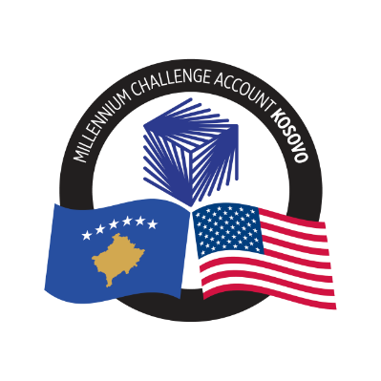
MCA-KOSOVO

CONTRACT AWARD NOTICE

Country | : | Kosovo
City/Locality | : | Prishtina
Funding Agency | : | Millennium Challenge Corporation
Buyer | : | Millennium Challenge Account – Kosovo

To promote transparency and in accordance with the MCC Accountable Entity Program Policy and Guidelines, MCA-Kosovo publishes the contract awards notice. A notice must be published at least monthly on the Accountable Entity website and identify the contracts signed within the last 30 days including contracts awarded by Limited Bidding, Direct Contracting and Sole Source Selection procedures.

The following contracts has been awarded during the period of July 2024.

Goods and Non-Consultant Services
Number and Name of the Procurement | Selected Offeror | Contract Amount | Contract Period | Scope of the goods/Non-Consultant Services
24-3005  Mobile voice & data package for MCA-Kosovo Staff | IPKO Telecommunications L.L.C. | Blanket Purchase Agreement | Blanket Purchase Agreement (BPA) with 1 Base year + 4 Option years (up to April 29, 2029) | To provide mobile voice & data package for MCA-Kosovo Staff when needed based on the unit prices included in the BPA.
24-3016(a)  Graphic Design Services for MCA-Kosovo | Asha SH.P.K. | Blanket Purchase Agreement | Blanket Purchase Agreement (BPA) – duration 12 months | To provide graphic design services to MCA-Kosovo when needed based on the unit prices included in the BPA
24-3016(b)  Graphic Design Services for MCA-Kosovo | Trembelat SH.P.K. |  | Blanket Purchase Agreement (BPA) – duration 12 months | To provide graphic design services to MCA-Kosovo when needed based on the unit prices included in the BPA.
24-3015  Taxi Services for MCA-Kosovo | Golden Taxi SH.P.K. | Blanket Purchase Agreement | Blanket Purchase Agreement (BPA) -duration 12 months | To provide Taxi Services for MCA-Kosovo when needed.

Note: Blanket Purchase Agreements (BPAs) are not contracts but agreements to contract. The contract occurs when an order is placed. Thus, there are no binding terms on either party.

