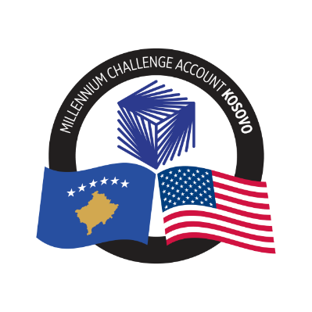
MCA-KOSOVO

CONTRACT AWARD NOTICE

Country | : | Kosovo
City/Locality | : | Prishtina
Funding Agency | : | Millennium Challenge Corporation
Buyer | : | Millennium Challenge Account – Kosovo
Period | : | October 2024

To promote transparency and in accordance with the MCC Accountable Entity Program Policy and Guidelines, MCA-Kosovo publishes the contract awards notice. A notice must be published at least monthly on the Accountable Entity website and identify the contracts signed within the last 30 days including contracts awarded by Limited Bidding, Direct Contracting and Sole Source Selection procedures.

The following contracts has been awarded during the period of October 2024.

Goods and Non-Consultant Services
Number and Name of the Procurement | Selected Offeror | Contract Amount | Contract Period | Scope of the goods/Non-Consultant Services
24-1011a  Office and kitchen supplies for MCA-Kosovo LOT 1 - Office Supplies | Europrint Group SH.P.K. | Blanket Purchase Agreement | Duration: four and a half (4.5) years from the contract signature date of October 1, 2024. | Office and kitchen supplies for MCA-Kosovo LOT 1 - Office Supplies, as needed, based on the unit prices included in the Blanket Purchase Agreement (BPA).
24-1011c  Office and kitchen supplies for MCA-Kosovo LOT 3 - Kitchen Supplies | Kulinare SH.P.K. | Blanket Purchase Agreement | Duration: four and a half (4.5) years from the contract signature date of October 2, 2024. | Office and kitchen supplies for MCA-Kosovo LOT 3 - Kitchen Supplies, as needed, based on the unit prices included in the Blanket Purchase Agreement (BPA).
24-1008  One vehicle for KOSTT PIU | AUTOTRADE SH.P.K. | EUR 44,900.00 | 120 days from the contract signature date: October 11, 2024. | Supply and delivery of one vehicle for Transmission System and Market Operator (KOSTT) Project Implementing Unit (PIU).
24-3018  Project Management Training for MCA-Kosovo Staff | Social Project Institute | US$ 12,000.00 | 18-hours training as per the course structure. | Training Service for MCA-Kosovo staff (24 participants) in project management, PMI-PMBoK (Project Management Body of Knowledge) and the Inter-American Development Bank’s PM4R (Project Management for Results).

Note: Blanket Purchase Agreements (BPAs) are not contracts but agreements to contract. The contract occurs when an order is placed. Thus, there are no binding terms on either party.

